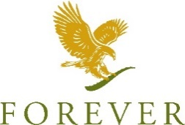

Welcome to Forever Living Products UK
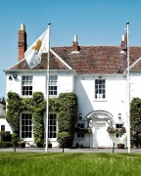

Index

A warm welcome from the Forever Family in the UK!

1_Welcome!
2_Order Products
3_Delivery Options
4_Sponsoring in the UK
5_Retail Customers
6_Trainings and Meetings
7_Bonus Payments
8_Product Centre and Contact Details
9_Opening Hours

A warm welcome
from the Forever Family
in the UK!

Thank you for your interest in forever UK. The following information is designed to help you to understand some of our basic procedures. It’s your gateway to all necessary information to sponsor people and buy your favourite products and accessories. Visit us at Head Office – we would love to meet you! If you have any further questions we are here to help you, so please do not hesitate to contact us for more information.
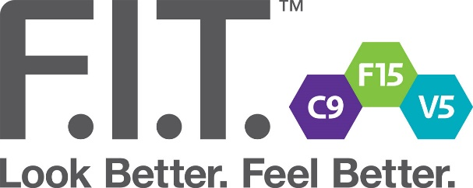

1_Welcome

As a visiting FBO you will need to be internationally sponsored into the UK.

You can ask your local office to do this for you, full activation will take up to 24 hours to complete.

Please use your full FBO 12-digit ID number for making purchases and sponsoring people in the UK.

2_Order Products

Ordering products from Forever couldn’t be easier and you can choose from several ways to place your order.
- Online at www.foreverliving.com
- (Europe – Great Britain – Forever Business Owner)
- Log in using your ID and the same password you use
in your country.
Forgot your password? Don’t worry, you can email
businessownersupport@flpuk.net and we will send you a new one!
(Please include your name, FBO ID & contact info)

- Call our order line: 01926 626 666
- (Mon-Fri 8.00am till 6.00pm, Sat 9.00am till 1.00pm)

- In Person at one of our product centres in London, Milton Keynes or Warwick.
Accepted Payment Methods:

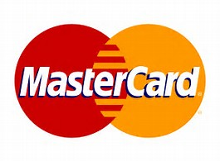
Minimum Order Requirement:
£50.00 minimum order on delivery/ £30.00 minimum on collection
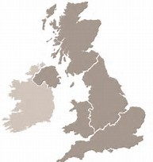
3_Delivery Options

Courier service is offered for all orders in the UK.

After becoming a Forever Business Owner in the UK the delivery charge is £6.98 for any orders up to the value of £500, if the order exceeds this amount the delivery will increase to £9.98.

Delivery of literature is sent via Royal Mail and therefore delivery is charged based on the weight of the items, however will not exceed £6.98.

All orders placed on the retail store incur a delivery charge. Shipping charges are inclusive of VAT.

- Orders weighing up to 1000g = £3.00
- Orders weighing between 1001g - 1500g = £5.00
- Orders 1501g and above are charged at £6.98

Visit one of our product centres (Milton Keynes, Warwick, London) and buy the products you love on the spot!

4_Sponsoring in UK

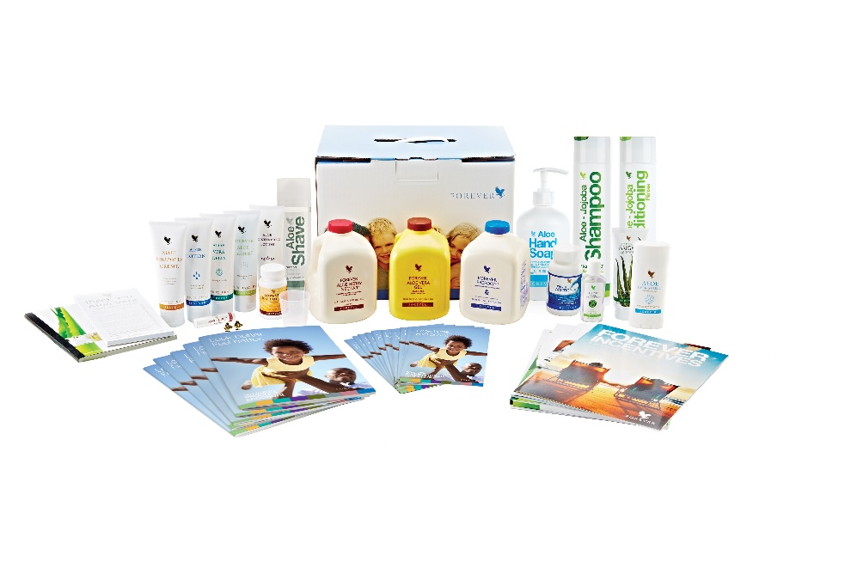
Grow your team while visiting in the UK easily by registering your new team members online through foreverliving.com.

Please see below link to the UK online application forms:
http://foreverliving.com/

Under the section Join my team; you will be given the two options of ordering either a Start Your Journey Pack or a C9 pack.

To enable to register as a Forever Business Owner in the UK you can sign up with a Start Your Journey Pack for £199.75, this will automatically place the new applicant at Assistant Supervisor level.
Alternatively, sign up can be with a Clean9 at £96.44 in either chocolate or vanilla worth 0.447 Case Credits.

Finally, a new applicant can sign up with products of their choice if they spend a minimum of £100 at Novus Customer price and the order does not exceed £200. Please note there is no online application form if the applicant decides to order individual products, this would need to be uploaded via drop box along with the order attached.

If the new applicant signs up with either a Clean9 or products of their choice they will need to achieve 2 case credits over the 2 consecutive months to become an Assistant Supervisor.

5_Retail Customers

Your Retail customers can place their orders at your FLP360 website or
by using your web link:
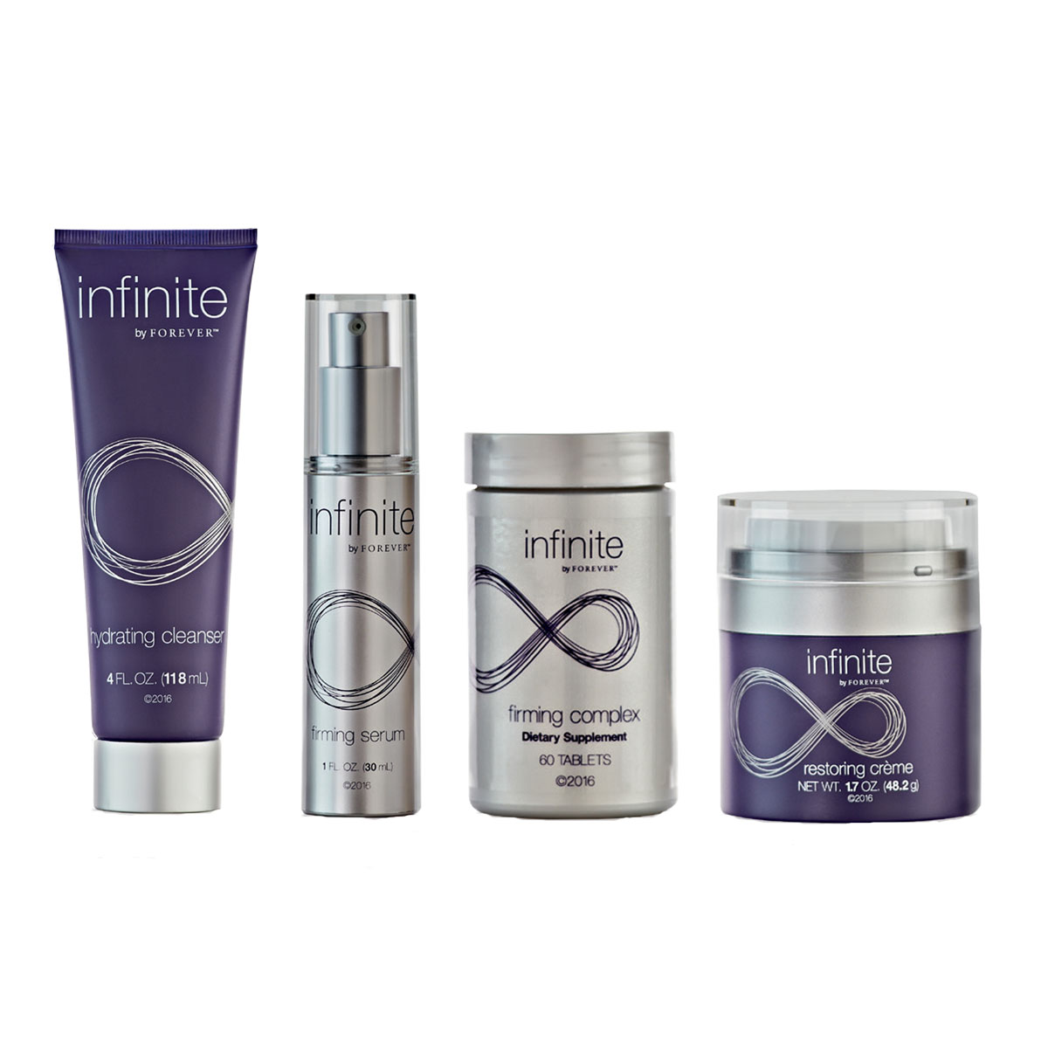
https://shop.foreverliving.com/retail/entry/Shop.do?store=GBR&language=en&distribID=IDNUMBER
This link cannot be shortened or edited as it will lose your credentials if edited.

We send your retail orders directly to your customer. Your retail customer can pay using Credit or Debit Card. Your retail profit will be paid according to the bonus payments (Please see Bonus Payments below)
All orders placed on the retail store incur a delivery charge. Shipping charges are inclusive of VAT.

- Orders weighing up to 1000g = £3.00
- Orders weighing between 1001g - 1500g = £5.00
- Orders 1501g and above are charged at £6.98

6_Trainings and Meetings

At present, all Business Presentations and Trainings are in English.

Product and business trainings are important for your own personal
Follow the Forever UK Events page on Facebook for more information.
development and the growth of your business.

Forever Spotlight

Success Express: Success Express is a superb opportunity for you to celebrate and network with thousands of Forever Business Owners from across the UK, but is also an event that allows Head Office the chance to formally acknowledge all your hard work. The trainings on offer are delivered by some of the top FBOs in the business and we promise that you’ll leave inspired, refreshed and raring to go! Book your place today.

Tickets for all Head Office trainings are available from events@flpuk.net. For more dates and information on Head Office events, please visit foreverknowledge.info or get a copy of the events and Training guide.

7_Bonus Payments

Currently FBO’s who live outside of the UK are paid via bank transfer direct to their account once the bonus has accumulated to £100. In December of each year this is reduced to £50 to try and clear as many as possible. Anything below £50 carries forward to the following year.

The other method we are using is FGP (Forever Global Pay) this is only up and running in the US so far with the UK next to join.

Not all countries have the facility to use FGP so they will continue to be paid direct to their bank.

For any further queries please contact bankenquiries@flpuk.net

8_Product Centres
Milton Keynes

38-39 Sunningdale House
Caldecotte Lake Drive
Caldecotte Lake Business Park
Milton Keynes
MK7 8LF

Contact Us

Business Owner Support:
01926 626 629
businessownersupport@flpuk.net

Order Fulfilment:
01926 626 666

Delivery Helpdesk: 01926 626670

Events:
01926 626 628
events@flpuk.net

Compliance & Regulatory:
compliance@flpuk.net

Product Enquiries:
productenquiries@flpuk.net

Forever Knowledge:
01865 592 772
subscriptions@foreverknowledge.info

Fulham

Alexander House
14-16 Peterborough Road
London
SW6 3BN

Warwick

Longbridge Manor
Warwick
Warwickshire
CV34 6RB

9_Opening Hours
Fulham Product Centre

Monday 11:00 am – 4:00 pm 6:00 pm – 8:00 pm
Tuesday 11:00 am – 4:00 pm 6:00 pm – 8:00 pm
Wednesday 11:00 am – 4:00 pm 6:00 pm – 8:00 pm
Thursday 11:00 am – 4:00 pm 6:00 pm – 8:00 pm
Friday 11:00 am – 2:00 pm
Saturday 12 noon – 5:00 pm
Sunday 12 noon – 5:00 pm

Warwick Product Centre

Monday 9:00 am – 5:00 pm
Tuesday 9:00 am – 5:00 pm
Wednesday 9:00 am – 5:00 pm
6:00 pm – 10:00 pm
Thursday 9:00 am – 5:00 pm
Friday 9:00 am – 5:00 pm
Saturday 9:00 am – 1:00 pm
Sunday Closed

Milton Keynes Product Centre

Monday 9:30 am – 7:00 pm
Tuesday 9:30 am – 8:00 pm
Wednesday 9:30 am – 2:00 pm
Thursday 9:30 am – 10:00 pm
Friday 9:30 am – 2:00 pm
Saturday 9:30 am – 2:00 pm
Sunday Closed

UK Head Office – Business Owner Support
01926 626 629

Monday 9:00 am – 6:00 pm
Tuesday 9:00 am – 8:00 pm
Wednesday 9:00 am – 5:00 pm
Thursday 9:00 am – 5:00 pm
Friday 9:00 am – 5:00 pm
Saturday 9:00 am – 1:00 pm
Sunday Closed

